Preface and Project Overview

For the purposes of convenience, I decided to temporarily put the “module-9” directory onto my desktop while I tested the codes. The final deliverable will follow the required file structure for the GitHub submission.
This project demonstrates the fundamentals of consuming RESTful Web APIs using Python’s requests library. The application tests network connectivity to external endpoints, issues HTTP GET requests, and processes the returned payload in both raw and structured formats. The execution is split into two primary workflows: verifying connection stability using an open astronaut tracking API, and retrieving, parsing, and formatting JSON data from a custom secondary web service.
The initial script (tutorial_api.py) establishes an HTTP connection to the Open Notify API. Upon receiving a successful status code (200 OK), the program parses the JSON response containing the current personnel aboard the International Space Station. A looping construct iterates through the payload, extracting individual astronaut names and their associated spacecraft to print a clean, human-readable summary.
Figure 1: Tutorial API Connection and Data Extraction
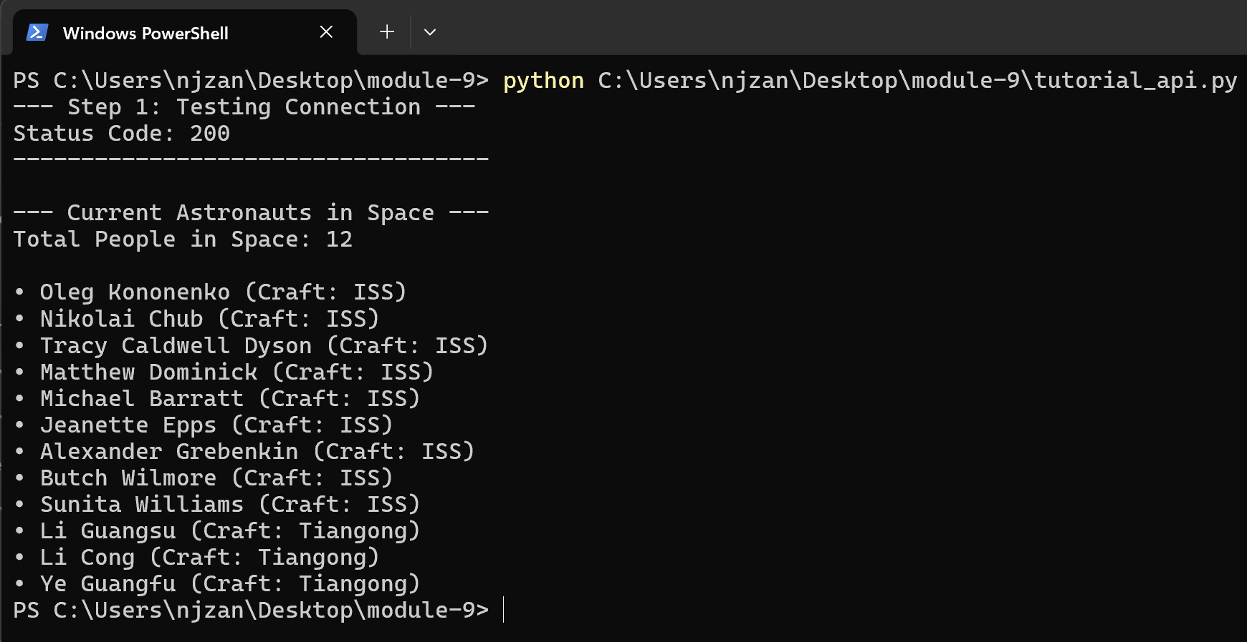

The secondary script (custom_api.py) expands on this logic by interacting with a public endpoint to demonstrate raw vs. formatted data handling. The script first outputs the raw HTTP status code, followed immediately by the unparsed JSON string (response.text). Finally, the script processes the payload using .json() to extract specific key-value pairs, presenting the structured output in a clean terminal layout. This two-stage output confirms both raw data transmission and accurate client-side data parsing.
Figure 2: Custom API Raw and Formatted Output
